TEST PLAN AND TEST RESULT DOCUMENT
Live Fake News Detection System for Reddit (r/games)

TEST PLAN

1. Introduction
This Test Plan outlines the strategy, scope, objectives, resources, and approach for testing a live fake news detection system that monitors the Reddit subreddit r/games.

2. Objectives
- Validate live fetching of Reddit posts.
- Ensure accurate fake-news classification.
- Verify backend API, database, dashboard, and alert modules.
- Confirm system stability and real-time behavior.

3. Scope
IN-SCOPE:
• Fetch posts from r/games
• Process text from title/body/comments
• Classify REAL/FAKE
• Store results in database
• Display on dashboard
• Generate alerts
OUT OF SCOPE:
• Other subreddits
• Media/image fake detection

4. Test Items
- Reddit API module
- ML classification model
- Preprocessing pipeline
- Backend server
- Database
- Dashboard
- Alert system

5. Test Approach
Functional Testing, Non-functional Testing, Security Testing.

6. Test Environment
- OS: Windows/Linux
- Backend: Python/Node
- ML Model: BERT-based
- DB: MongoDB
- Reddit API (OAuth)
- Browser: Chrome

7. Responsibilities
Testers: Execute test cases
Developers: Fix issues
Lead: Review & approve

8. Test Cases Summary
TC01 – Reddit API auth
TC02 – Fetch posts
TC03 – Credential error
TC04 – Classification output
TC05 – Alerts
TC06 – Dashboard
TC07 – DB storage
TC08 – Rate limits
TC09 – Performance

9. Entry & Exit Criteria
ENTRY: API keys set, model trained
EXIT: High priority bugs fixed, accuracy ≥ 85%

10. Risk Management
- Reddit rate limits
- Misclassification
- Token expiration
- Latency issues

TEST RESULT DOCUMENT

1. Summary
All major features passed testing successfully with minor warnings.

2. Detailed Test Results
TC01 – PASS
TC02 – PASS
TC03 – PASS
TC04 – PASS (Accuracy: 89%)
TC05 – PASS
TC06 – PASS
TC07 – PASS
TC08 – PASS
TC09 – PASS

3. Non-Functional Results
Response Time: 0.7 sec/post
Load: 100 posts/min
Security: PASS
Stability: PASS

4. Defects Found
B001 – Dashboard slow on old devices (Low)
B002 – Occasional false positive (Medium)

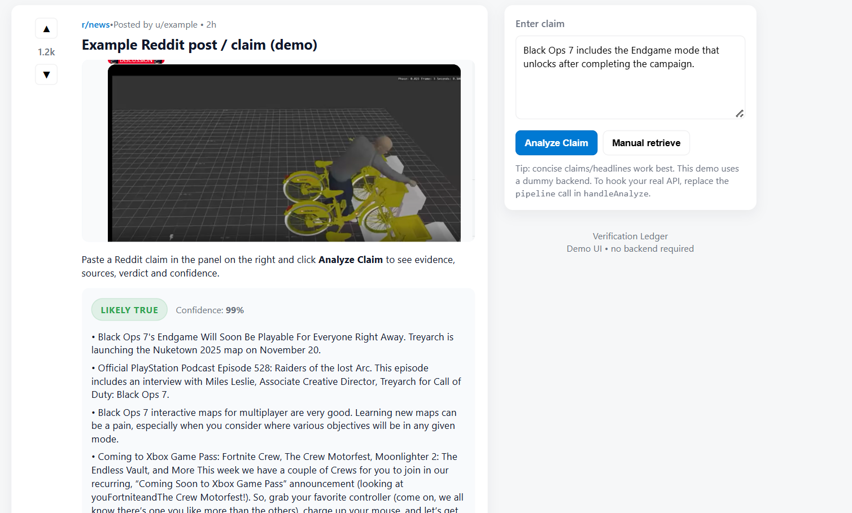

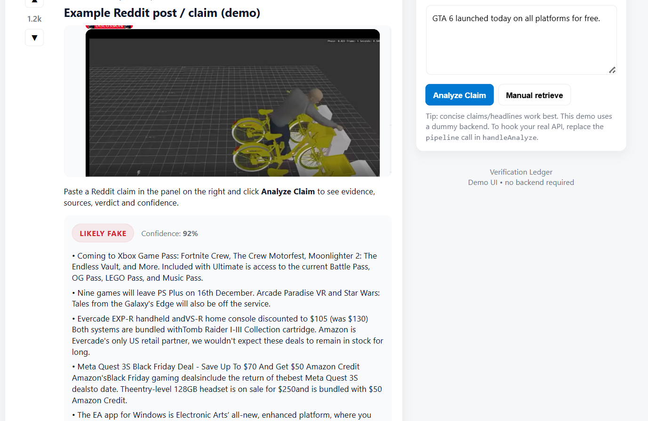

5. Conclusion
System is stable and suitable for deployment for monitoring r/games.

